Bandit Level 9
DG Interns Hub | Week 1 | OverTheWire Bandit Writeup

Objective
Identify the unique line in a file.

Activity summary
Suggested learning command / approach: sort data.txt | uniq -u. Use only on the authorized OverTheWire training environment.

Key learning
Sorting and identifying unique text.

Evidence
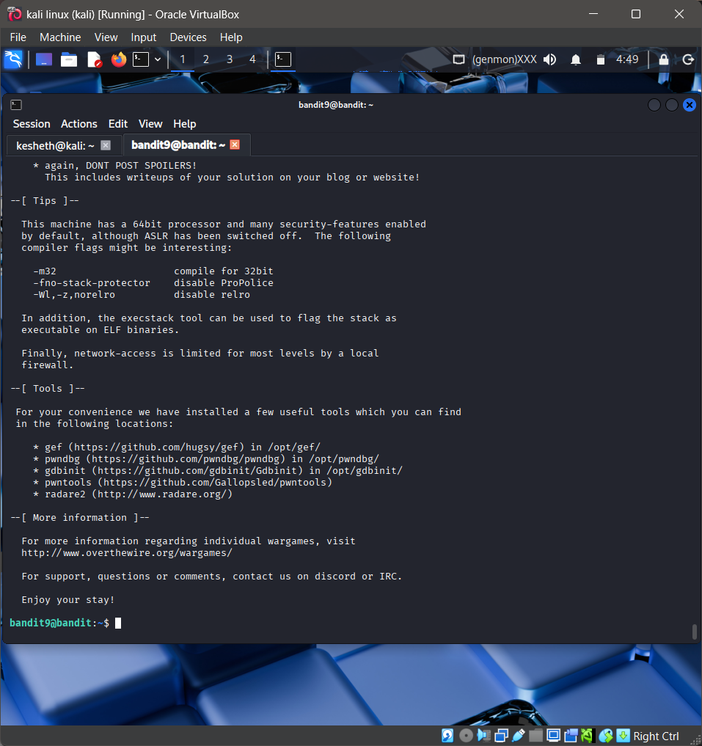
Screenshot: Bandit_Level_9.png
The screenshot is evidence of level activity/login; it may not show every solution step. No passwords are reproduced.

